PRACTICAL – 1
Task 1:
1.Execution
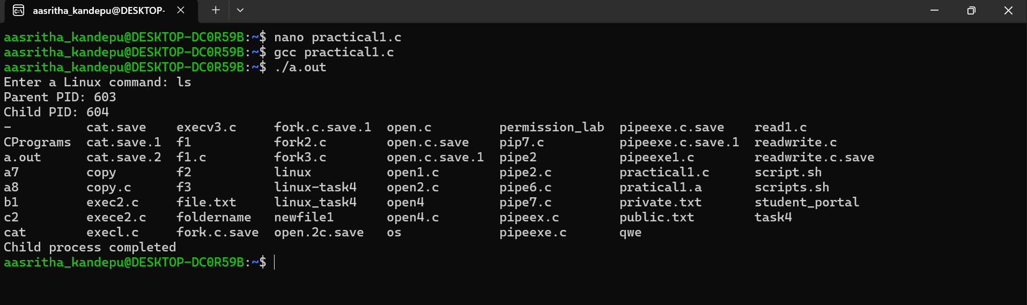
Task 2:
1.uname
2. lscpu
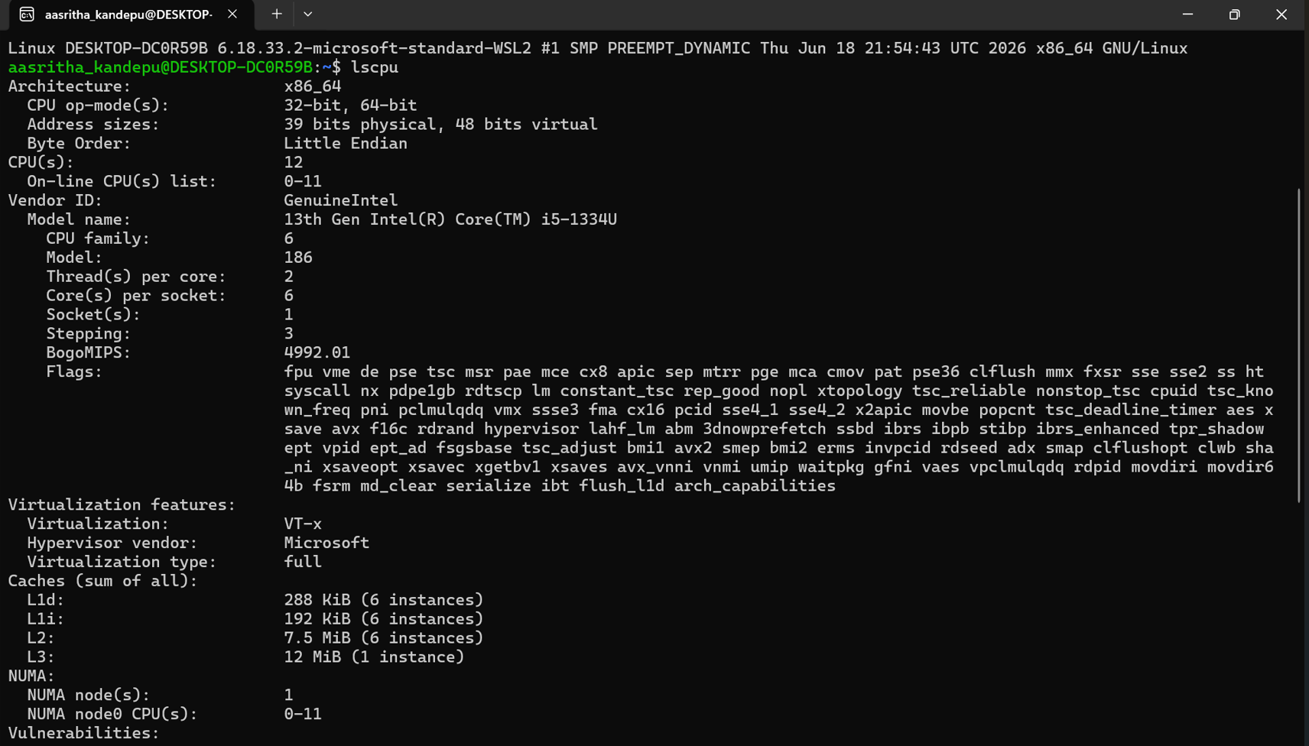
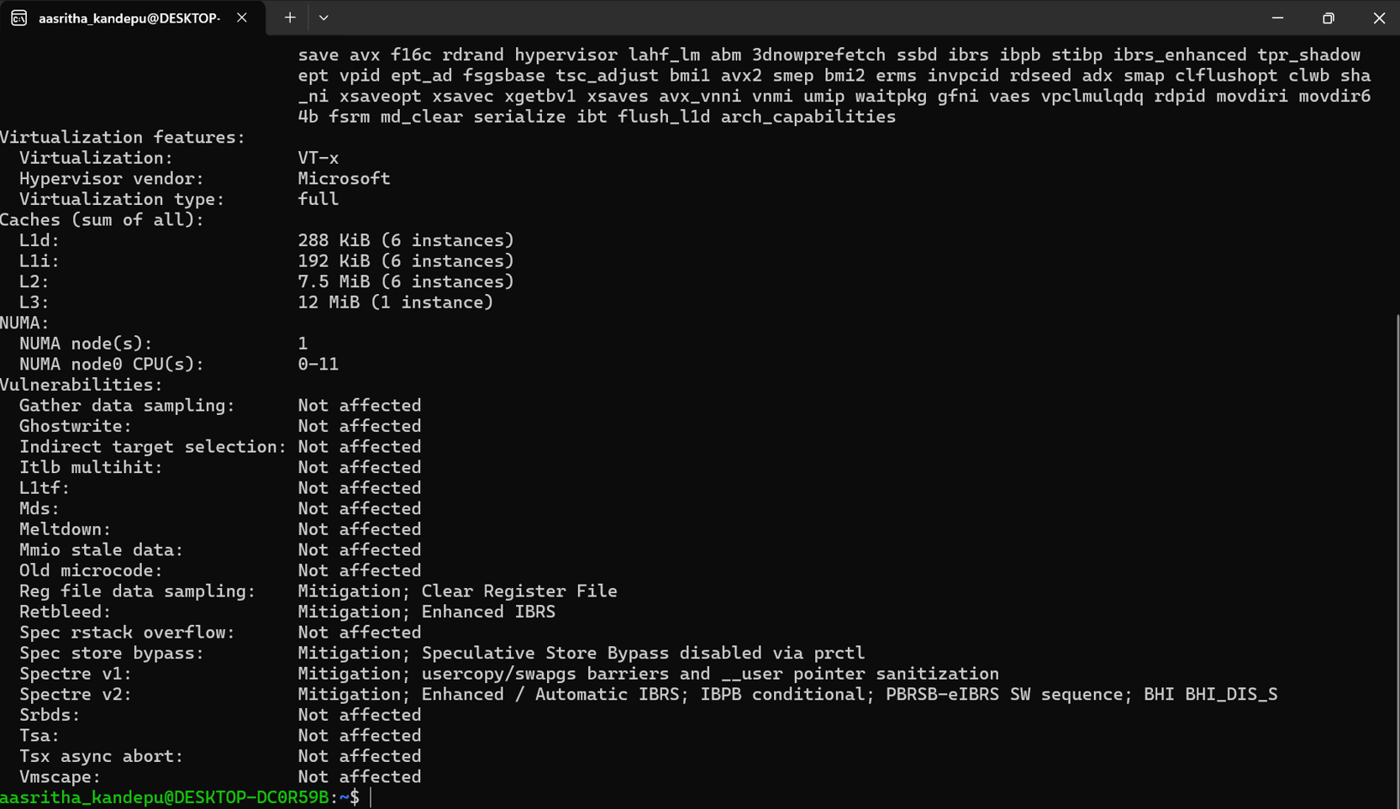
3.lsblk
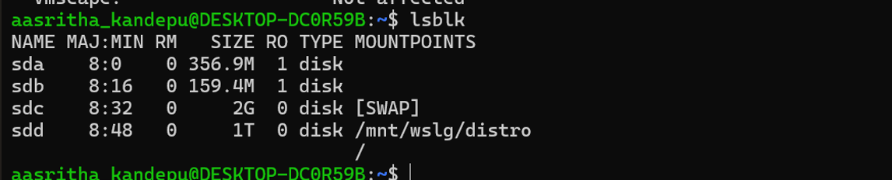
4. ps
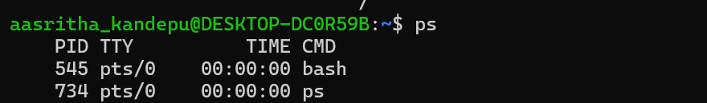
5. top
